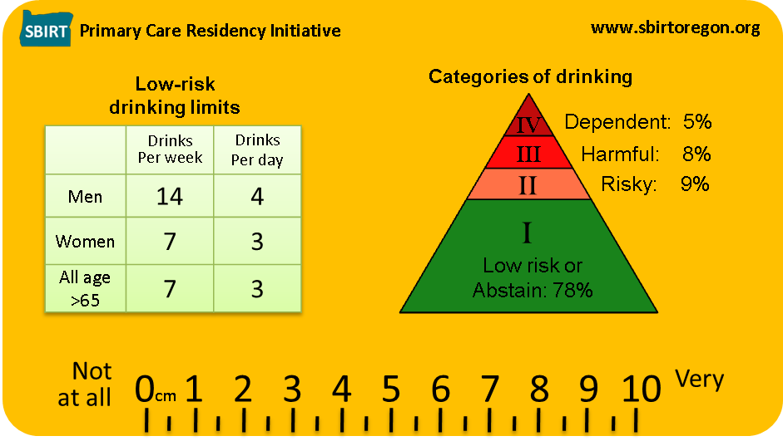
Screening and Brief Intervention Tools

Screening and Brief Intervention Tools

I Low Risk/Abstain  AUDIT: 0-7 DAST: 0 | II Risky  AUDIT: 8-15 DAST: 1-2 | III Harmful  AUDIT: 16-19 DAST: 3-5 | IV Dependent  AUDIT: 20+ DAST: 6+

I Low Risk/Abstain  AUDIT: 0-7 DAST: 0 | II Risky  AUDIT: 8-15 DAST: 1-2 | III Harmful  AUDIT: 16-19 DAST: 3-5 | IV Dependent  AUDIT: 20+ DAST: 6+

